RESERVATION FORM

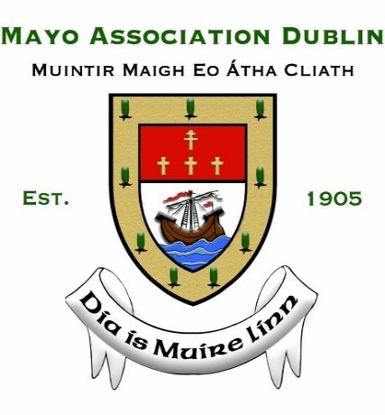
THE YEW TREE BALL
(incorporating the 2019 Annual Awards)

Venue: The Ballsbridge Hotel, Dublin 4
Date: Saturday 9 February 2019
Tickets: €100

I wish to reserve __ ticket(s) OR I wish to reserve a table of 10/12 (please circle) and clearly include guests’ names (in capitals letters below:

Name: Name: Name:

Name: Name: Name:

Name: Name: Name:

Name: Name: Name:

Select One of the Following Methods of Payment:
- By cheque, made payable to Mayo Association Dublin
- By interbank transfer to IBAN: IE48 BOFI 9001 1341 8185 38 BIC: BOFIIE2D
- Online payment via www.mayoassociationdublin.com/events

PLEASE NOTE: Bookings cannot be accepted without prior payment. As this event is booked out in advance annually – tickets are sold on a first-come first-served basis.

Name: Company:

Address:

Telephone: Email:

Return completed booking form and your payment before Friday 1 February 2019 to:
Michael Kealy, Treasurer, Mayo Association Dublin, 19 Torquay Wood, Foxrock, Dublin 18, or e-mail: treasurer@mayoassociationdublin.com

Refund/Cancellations: Refunds can only be provided for cancellations, which must be received by post or email (to treasurer@mayoassociationdublin.com) 48 hours prior to the event.

