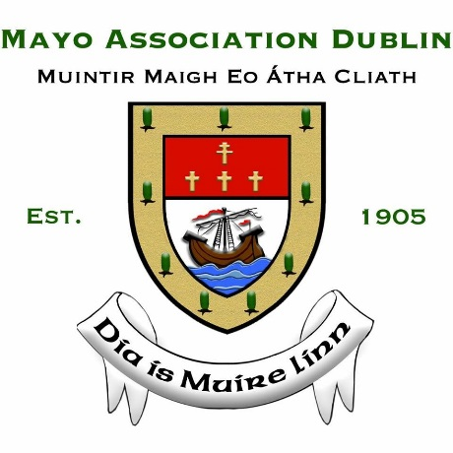
ANNUAL BUSINESS LUNCH 2019

BOOKING FORM

Date: Friday 1 November 2019
Guest Speaker: Peter Hynes, CEO, Mayo County Council
Venue: Intercontinental Hotel, Ballsbridge, Dublin 4
Time: 12.30pm start (includes three-course lunch)
Ticket Price: €85 per person

Name: Company:

Address:

Mobile: Landline:

Email:

I wish to reserve ____ place(s) OR I wish to reserve a table of 10/12

Please include your guest(s) names below
Name _______________ | Name _______________ | Name _______________
Name _______________  Name _______________ | Name _______________  Name _______________ | Name _______________  Name _______________
Name _______________ | Name _______________ | Name _______________

Please select one of the following methods of payment

- By cheque, the sum of made payable to Mayo Association Dublin.

- Direct payment transfer to IBAN: IE48 BOFI 9001 1341 8185 38 BIC: BOFIIE2D

Please email the completed Booking Form to treasurer@mayoassociationdublin.com no later than Wednesday 16 October, or alternatively post it to:
Cian Durkan, Treasurer, Mayo Association Dublin, c/o Flynn O’Driscoll, No.1 Grant’s Row, Dublin 2
(NOTE: Booking forms received after this date may not be accepted by the Association).

No table will be fully reserved until confirmation of payment has been received.

Refund/Cancellations: Refunds can only be provided for cancellations, which must be received by post or email 48 hours prior to the event.

