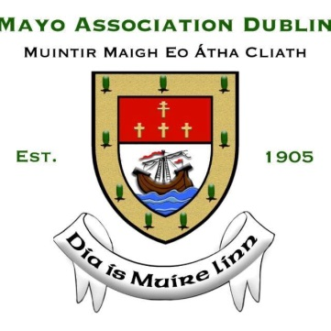

|  |
| --- |
| **APPLICATION FORM**  **Mayo Association Dublin Schools’ Debating Competition 2019** |

**Name of School:** _____________________________

**Address:** _____________________________

_____________________________

**Teacher/Mentor:** _____________________________

**Contact details**  Email: _____________________________

Phone: _____________________________

**Number of Teams Entered:** (Fee of €50 per team is applicable)

(Max No. of Teams: 2)

**Names of Students:** 1.______________________________

2.______________________________

1.______________________________

2.______________________________

**Substitute Team Members:** _______________________________

_______________________________

_______________________________

**Please select one of the following methods of payment**

* *Pay by cheque, made payable to ‘****Mayo Association Dublin’*** *and send together with Application Form to: Cian Durkan, Treasurer, Mayo Association Dublin, Flynn O’Driscoll, No.1 Grant’s Row, Dublin 2*
* *Direct Payment Transfer to* ***IBAN:*** *IE48 BOFI* *9001 1341 8185 38* ***BIC:*** *BOFIIE2D* ***If paying by direct transfer please note the school name on the transfer***