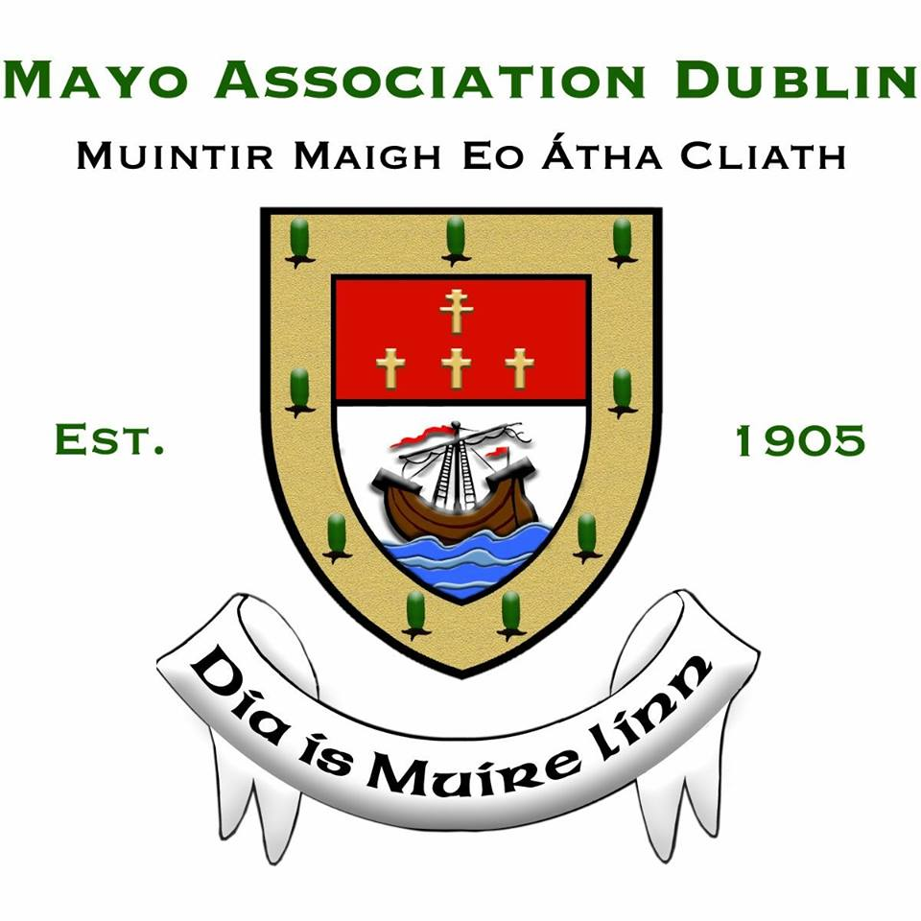

NOMINATION ENTRY FORM & GUIDELINES

‘MAYO PERSON OF THE YEAR’ AWARD

To qualify for this award, the nominated person must have been born in Mayo, be of Mayo parentage, or who has lived for not less than seven years in Mayo. And finally, in the opinion of our panel of three independent adjudicators, he/she must have made an exceptional contribution to Mayo or its people.

Details of Nominee

Name of Nominee:

Address of Nominee:

Phone Number:

Email Address:

Place of Birth:

Is the Nominee of Mayo Parentage?

Place of Residence in Mayo:

Length of time in Place of Residence in Mayo:

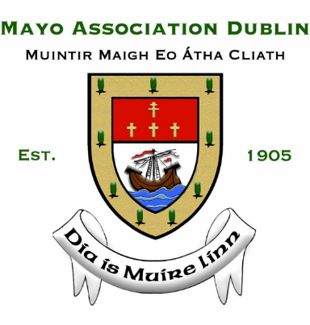
DETAILS OF PROPOSER AND SECONDER

Name of Proposer:

Address of Proposer:

Phone Number:

Email Address:

Name of Seconder:

Address of Seconder:

Phone Number:

Email Address:

Please INCLUDE the following information
- Details of the Nominee’s background.
- Reasons you wish to nominate the Nominee as the ‘Mayo Person of the Year’ and provide his/her achievements to support the nomination.
- Any philanthropic or charitable work carried out by the Nominee in the county.
- Any business carried out or created by the Nominee that benefits Mayo or its people.
- Has any community work been carried out by the Nominee?
- How does Nominee support the promotion of the county and/or its people?
- Any testimonials or references to support the nomination.
- Attach any documentation that you believe may be of relevance, for example, press cuttings, brochures, to support the nomination.
- The Nominee must be available to attend (a) the Press Launch on Thursday 16 January 2020 and (b) the Awards Dinner on Friday 14 February 2020 in the Ballsbridge Hotel.

Detailed nomination entries (no less than 10 pages and no more than 30 pages) should be submitted (in triplicate and in hard copy) and forwarded to:
Bernardine MacBride Walsh, Honorary Secretary, Mayo Association Dublin, 228 The Waterside, Charlotte Quay, Dublin 4.

Nomination entries may also be emailed to secretary@mayoassociationdublin.com

Please Note: The deadline for submission of entries is Friday 3 January 2020.

