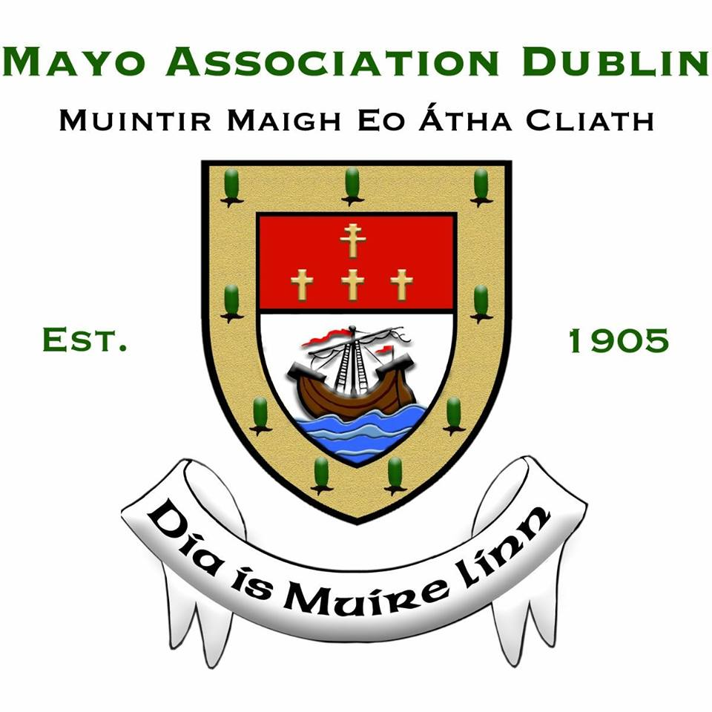

NOMINATION ENTRY FORM & GUIDELINES

‘MEITHEAL OF THE YEAR’ AWARD

The ‘Meitheal of the Year’ Award will be presented to a voluntary group or organisation based in Mayo, whose majority of its membership was born in Mayo or of Mayo parentage and who, in the opinion of the adjudicators, has achieved the greatest distinction or done most for the county or its people.

Details of Nominee

Name of Nominated Voluntary Group/Organisation:

Address:

Phone Number:

Email Address:

Membership of Group/Organisation:

Period of time the Nominated Voluntary Group/Organisation is in existence.

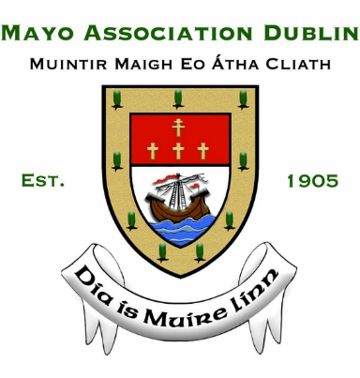
DETAILS OF PROPOSER AND SECONDER
Name of Proposer:

Address of Proposer:

Phone Number:

Email Address:

Name of Seconder:

Address of Seconder:

Phone Number:

Email Address:

Please INCLUDE the following information
- Background details of the Nominated Voluntary Group/Organisation.
- The aims/aspirations of the Nominated Voluntary Group/Organisation.
- Reasons you wish to nominate the Nominated Voluntary Group/Organisation.
- Applicable achievements of the Nominated Voluntary Group/Organisation to support the nomination.
- The work carried out by the Nominated Voluntary Group/Organisation in the county.
- The benefits of community work or other tasks undertaken by Nominated Voluntary Group/Organisation for Mayo or its people.
- How the Nominated Voluntary Group/Organisation supports the promotion of the county, and or its people.
- Provide testimonials or references to support the nomination.
- Provide documentation of relevance, for example, press cuttings, brochures, fundraising drives and photographs of projects to support the nomination.
- The Nominated Voluntary Group/Organisation must be available to attend
(a) the Press Launch on Thursday 16 January 2020 and (b) the Awards Dinner on Friday 14 February 2020 in the Ballsbridge Hotel.

Detailed nomination entries (no less than 10 pages and no more than 30 pages) should be submitted (in triplicate and in hard copy) and forwarded to:
Bernardine MacBride Walsh, Honorary Secretary, Mayo Association Dublin, 228 The Waterside, Charlotte Quay, Dublin 4.

Nomination entries may also be emailed to secretary@mayoassociationdublin.com

Please Note: The deadline for submission of entries is Friday 3 January 2020.

