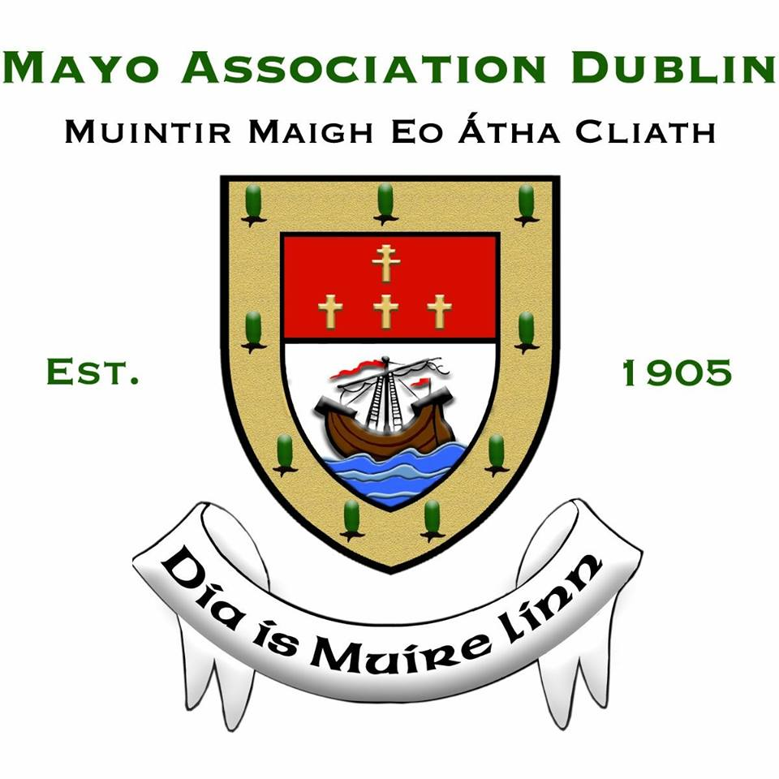NOMINATION ENTRY FORM & GUIDELINES

YOUNG MAYO PERSON OF THE YEAR AWARD

To qualify the young person must be over 17 and under 25 years of age (as of 1 January 2020), living in Mayo or was born or lived in Mayo for seven years. The award will serve to recognise any endeavours by the young person, which has provided significant social, community, leadership, or economic benefit to society, and must also reflect positively on the county.

DETAILS OF NOMINEE
Name of Nominee:

Address of Nominee:

Phone Number:

Email Address:

Place of Birth:

Is the Nominee of Mayo Parentage?

Place of Residence in Mayo:

Length of time in Place of Residence in Mayo:

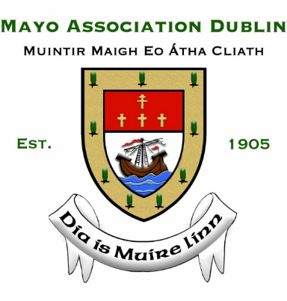
DETAILS OF PROPOSER AND SECONDER
Name of Proposer:

Address of Proposer:

Phone Number:

Email Address:

Name of Seconder:

Address of Seconder:

Phone Number:

Email Address:

Please PROVIDE the following information:
- Details of the Nominee’s background.
- Reasons you wish to nominate the Nominee as ‘Young Mayo Person of the Year’ and provide his/her achievements to support the nomination.
- Any philanthropic or charitable work carried out by the Nominee in the county.
- Any business carried out or created by the Nominee that benefits Mayo or its people.
- Has the Nominee carried out any community work?
- How does Nominee support the promotion of the county and/or its people?
- Any testimonials or references to support the nomination.
- Any documentation which you believe may be of relevance, for example, press cuttings, brochures, to support the nomination.
- The Nominee must be available to attend (a) the Press Launch on Thursday 16 January 2020 and (b) the Awards Dinner on Friday 14 February 2020 in the Ballsbridge Hotel.

Detailed nomination entries (no less than 10 pages and no more than 30 pages) should be submitted (in triplicate and in hard copy) and forwarded to:

Bernardine MacBride Walsh, Honorary Secretary, Mayo Association Dublin, 228 The Waterside, Charlotte Quay, Dublin 4.

Nomination entries may also be emailed to secretary@mayoassociationdublin.com

Please Note: The deadline for submission of entries is Friday 3 January 2020.

