MEMBERSHIP APPLICATION FORM

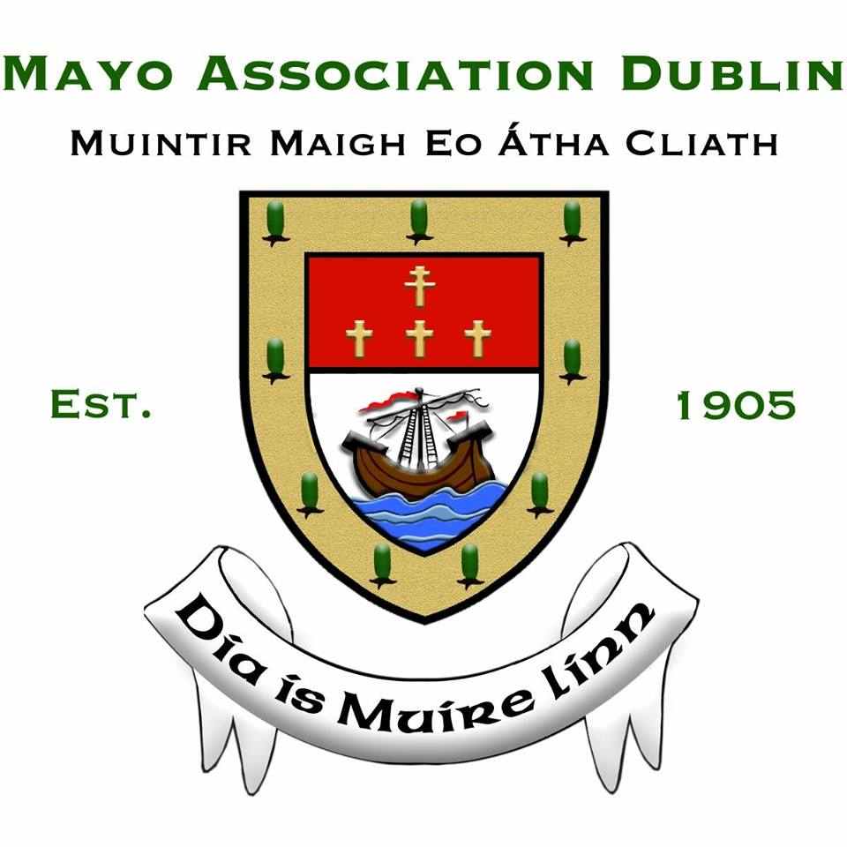

To:
The Secretary,
Mayo Association Dublin,
1 Limelawn Row,Clonsilla
Dublin 15

I wish to apply for membership of the Mayo Association Dublin. I confirm that I was born in Mayo, of Mayo descent and I am resident and/or working in Dublin City or County as at the date of my application for membership.

I am providing my personal data to the Association for the purposes of processing my application for membership, and I understand that in providing this data, I will become a Lifetime Member of the Association – unless I request to revoke my membership.

I consent to the use of my personal data by Mayo Association Dublin in order to maintain my membership, contact me about upcoming events, and send me newsletters and other relevant correspondence that pertains to my membership of the Association.

I am aware that my photograph or video image may be taken whilst attending or participating at events connected with the Association and I consent to it being used by the Association for items such as event programmes, year books, event reports, local media, and the Association’s website or social media channels.

I understand that I can resign my membership by writing to the Association and my personal data will then be erased. I agree to abide by the rules of the Association.

NAME (BLOCK CAPS):

PLACE/RESIDENCE (MAYO):
CURRENT ADDRESS:

LANDLINE No.:

MOBILE No.:
EMAIL: (BLOCK CAPS):

PLEASE NOTE: A membership fee OF €25 APPLIES
Make cheque, bank draft or postal order payable to ‘Mayo Association Dublin’.
Enclose it together with Membership Form and post to:
Maeve McLoughlin, Treasurer, Mayo Association Dublin,
79 Seafield Crescent, Booterstown, Co. Dublin, A94D6C4.

Alternatively you may lodge your membership fee to our bank account:
Muintir Mhaigheo, Bank of Ireland, 88 Lower Camden St, Dublin 2
IBAN: IE48 BOFI 9001 1341 8185 38
BIC: BOFIIE2D

Please include your details, so that we can identify who made the lodgement.

Mayo Association Dublin is an unincorporated Association of private members. We will store your personal data for the duration of your membership unless you revoke your membership. The Association will not share your personal data with any other person without your consent. Your personal data will be processed only for the legitimate purposes of your membership of the Association.

