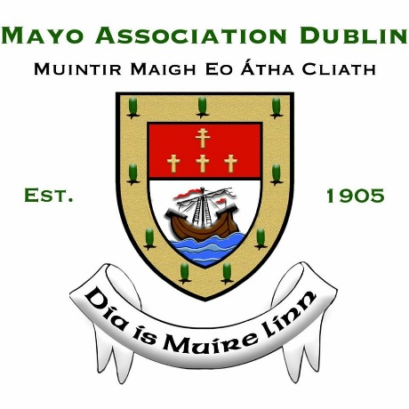
RESERVATION FORM
Mayo Association Dublin
(Muintir Mhaigh Eo Atha Cliath)
The Virginia Gallagher Mayo Person of the Year
and
The Paddy Joe Moran Meitheal Awards Luncheon

Venue: Intercontinental Hotel, Ballsbridge, Dublin 4
Date: Friday 8th March 2024 - Seating at 12:30pm
(includes three-course lunch)
Ticket Price: €120 per person

Name: Company:

Address:

Mobile: Email:

If booking a full table, please state name of table (to appear on guest list at venue):

___________________________________________________________________________

I wish to reserve ____ place(s) OR I wish to reserve a table of 10/12

Please include your guest(s) names below
Name _______________ | Name _______________ | Name _______________
Name _______________  Name _______________ | Name _______________  Name _______________ | Name _______________  Name _______________
PLEASE SELECT ONE OF THE FOLLOWING METHODS OF PAYMENT

- By cheque, the sum of made payable to Mayo Association Dublin.

- Direct payment transfer to IBAN: IE48 BOFI 9001 1341 8185 38 BIC: BOFIIE2D

Please email the completed reservation form to treasurer@mayoassociationdublin.com by the 1st of March.
(NOTE: Booking forms received after this date will not be accepted by the Association).
No table will be fully reserved until confirmation of payment has been received.
Refund/Cancellations: Refunds can only be provided for cancellations, which must be received by email 48 hours prior to the event.

